**Setting leak alerts eyeonwater**

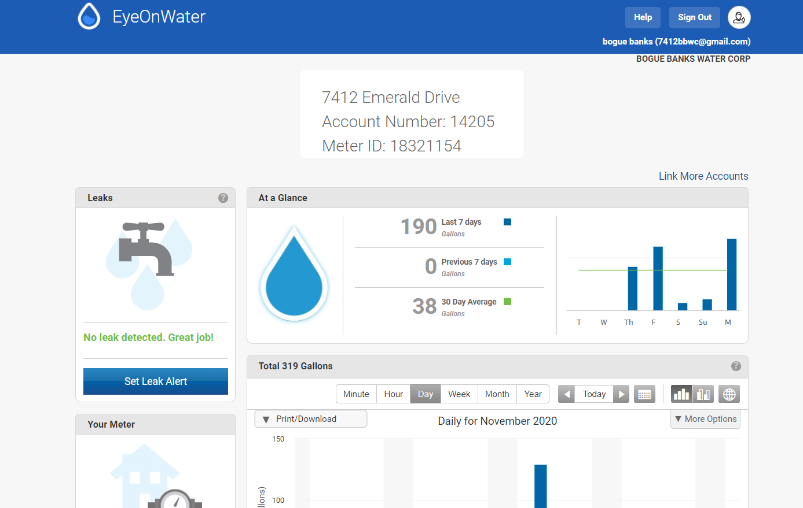

Login to eyeonwater account

Click on set leak alert on the top left of screen

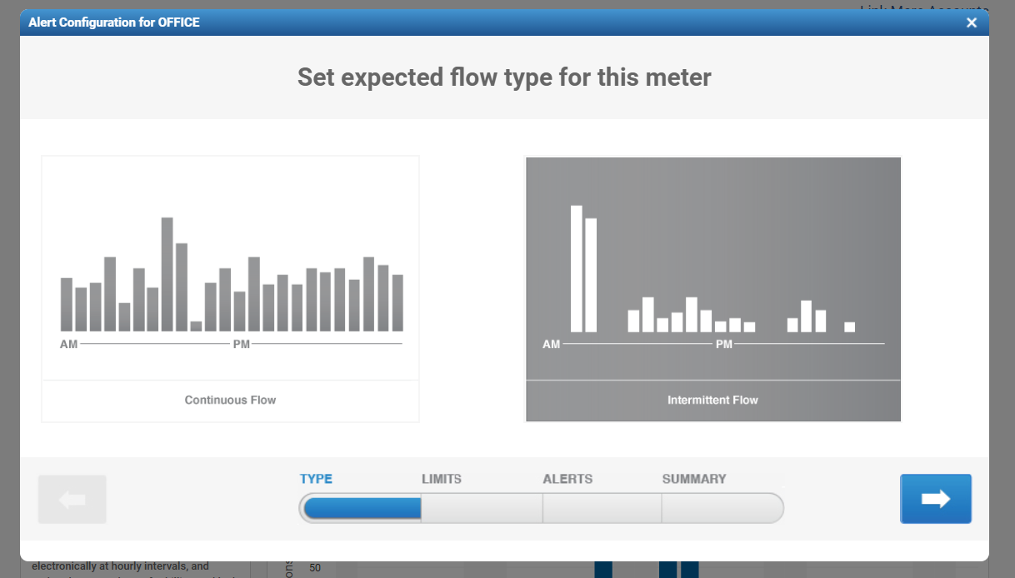

Select intermittent flow unless continuous flow is expected

Click the blue arrow to go to the next screen

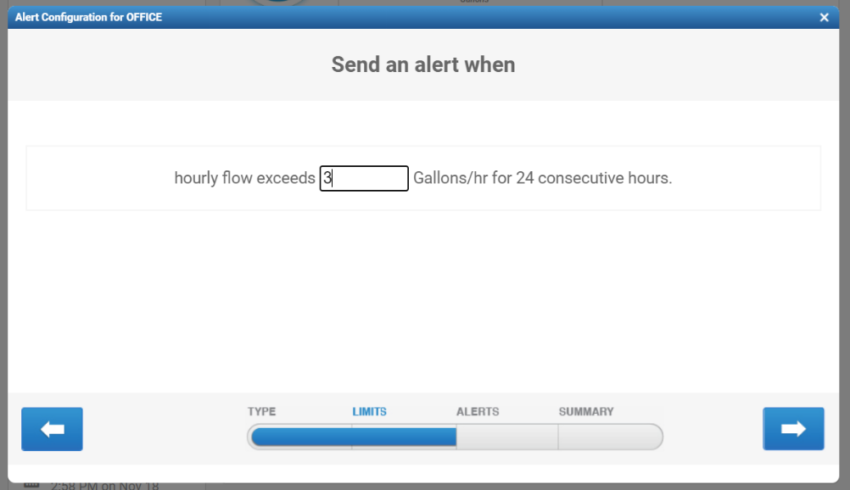

For permanent residents set between 1-3 gallons

If this is a vacation property should set to 1 gallon

Click the blue arrow to continue to next page

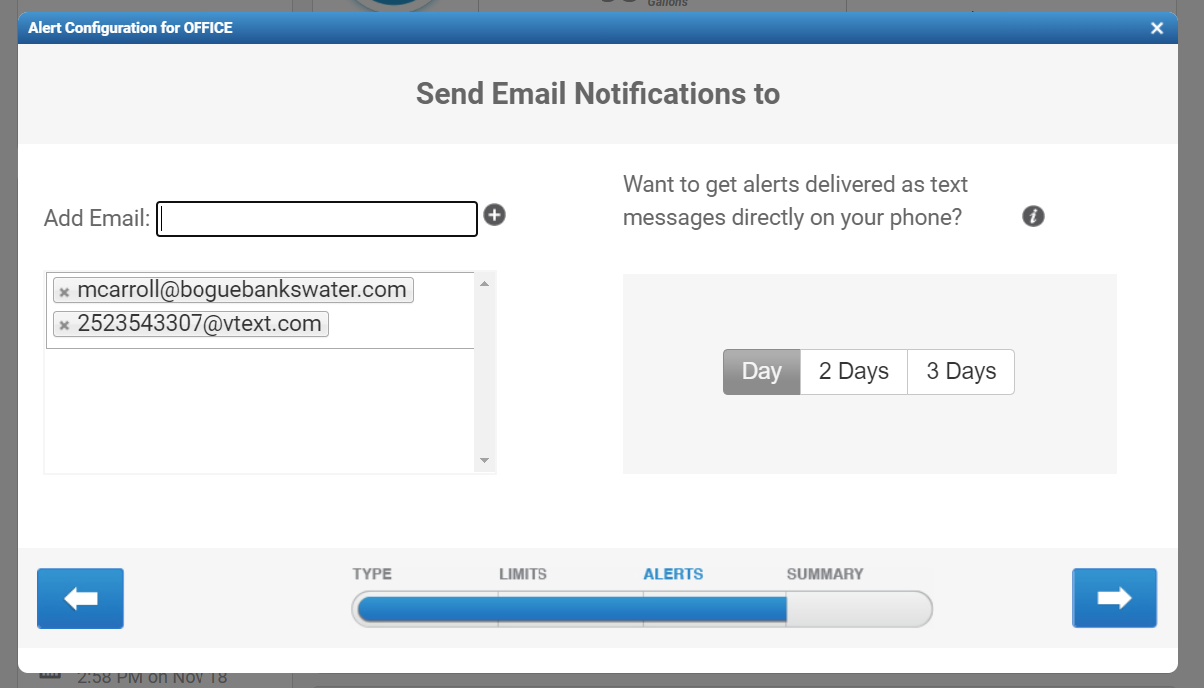

Here you can set up to send email notifications and/or text notifications

You can add as many email or phone numbers – also you can remove them from this screen

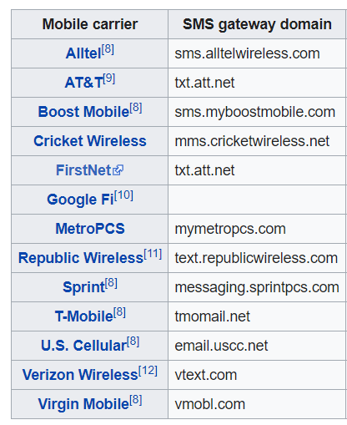

Depending on your wireless carrier you will input phone number followed by @ and the SMS Gateway domain

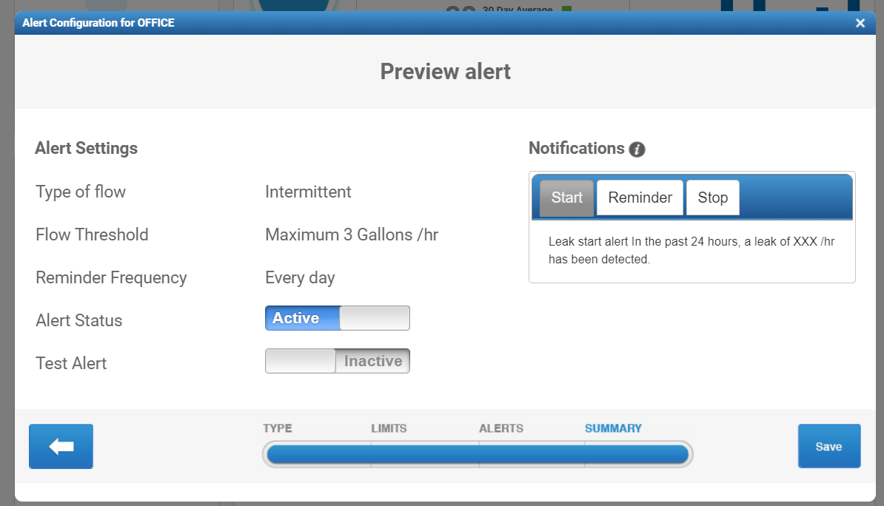

Here you can select to set Alert status to ACTIVE and Test Alert to ACTIVE and then click save

You should receive an email and/or text for test notification soon after