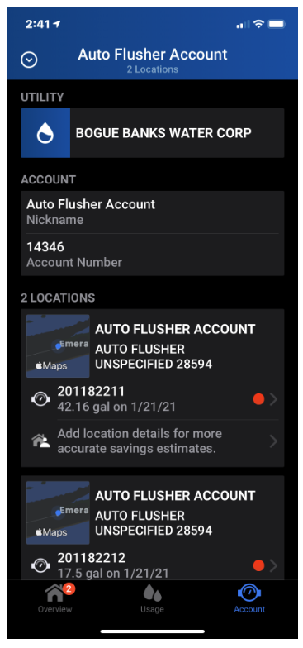

Setting leak alerts with IPHONE

From the account screen click the account icon at the bottom of the screen

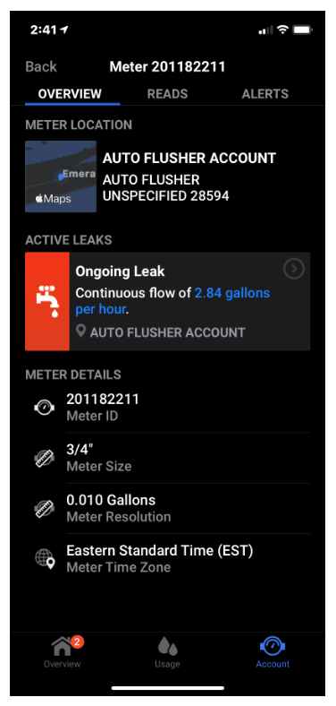

Next you will need to click over to the ALERTS tab at the top of the screen

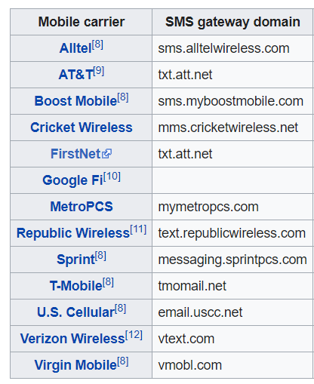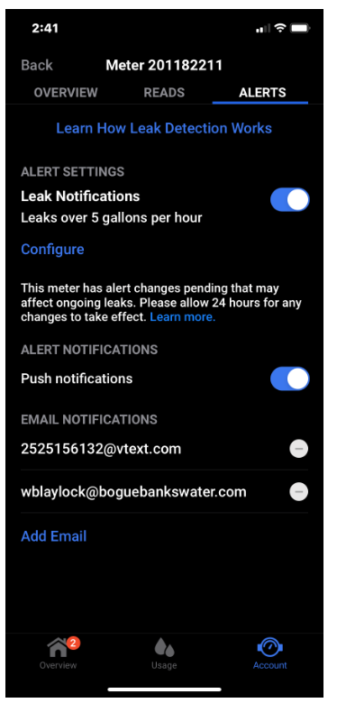

Turn the leak notification push button on

-set the alerts to your preference

-Once you are to where you are adding email notifications, you can put your email and/or phone #

-If your cell provider is Verizon you will need to put your#@vtext.com