**SETTING LEAK ALERTS ON ANDORID APP**

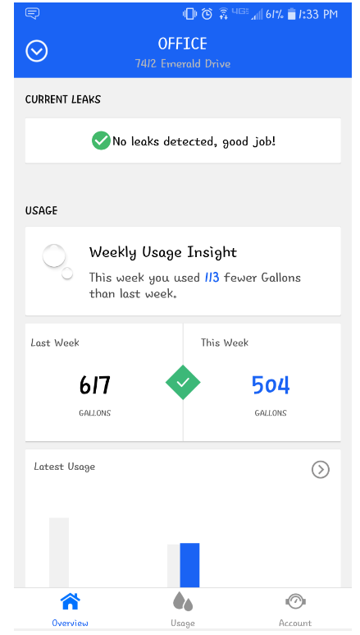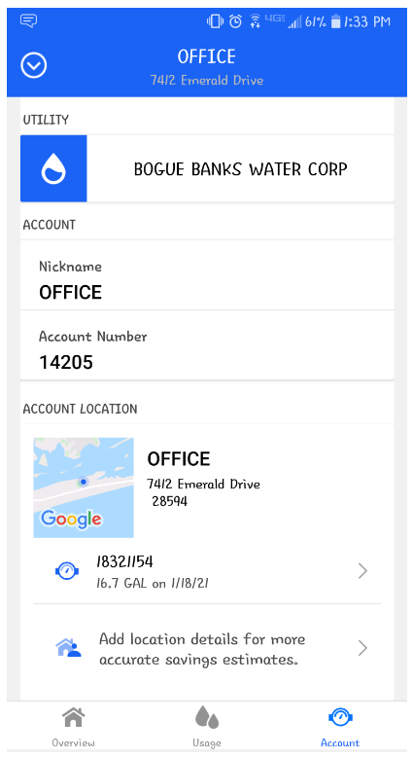

**CLICK THE ARROW BESIDE THE METER NUMBER**

**CLICK ON THE ACCOUNTS ICON AT THE BOTTOM OF THE SCREEN**

**LOG IN TO YOUR EYE ON WATER ACCOUNT**

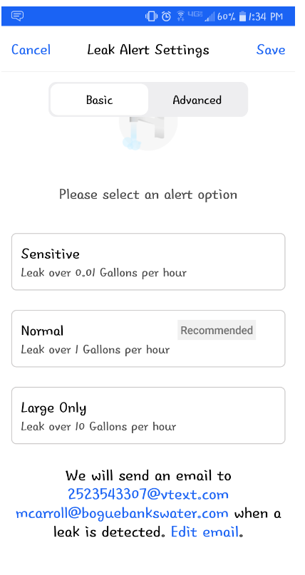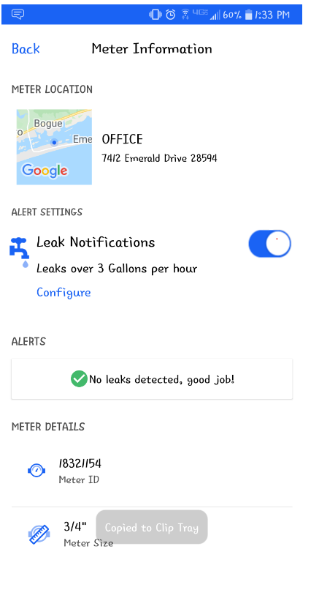

**SET YOUR ALERT TO YOUR PREFRENCE AND SELECT SAVE**

**CLICK THE TOGGLE ON BESIDE LEAK NOTIFICATIONS AND THEN SELECT CONFIGUE**