BOGUE BANKS
WATER NEWS

Winter is here!

We are on the sunny Crystal Coast, but we do occasionally get freezing temperatures. Here are some tips to help keep your pipes from freezing:
1. Locate any water lines at your home in unheated areas – crawlspace, outside showers, etc.) and insulate them. You can purchase ‘pipe sleeves’ or ‘heat tape’ but even ¼” of newspaper or other methods of wrapping your pipes can provide significant protection in areas that do not have frequent or prolonged freezing temps.
2. Keep garage doors closed if there are water supply lines in the garage.
3. Open kitchen and bathroom cabinet doors to allow warmer air to circulate around the plumbing.
4. Let cold water drip from faucets served by exposed pipes. Even a trickle can help prevent the pipes from freezing.
5. If you will be away from home during the cold weather, leave your thermostat set to at least 55 degrees F.

Winterizing your home

Many of you, our valued customers, do not live here year round. We would like to take this time to remind you of the importance of winterizing your vacant home. Just a few precautionary steps can save a lot of headache and plumbing bills, not to mention prevent some major damage to your home. BBWC recommends to have a licensed plumber perform a home winterization. Key steps to winterizing your home include:
- Setting your thermostat to a minimum of 55 degrees F
- Turning off the water supply to the home at the customer valve, not the BBWC angle valve.
- Draining all water from household lines.
- Insulating any exposed water lines.
Meter Tampering Fines and
Customer valve vs BBWC valve
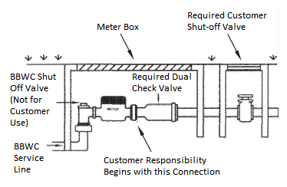
The BBWC Shut-Off Valves are not designed for frequent use, they will wear out and break. For this reason, we require every property to have a functioning customer valve in place at the street. This is the valve you should use any time you need to turn off the water. Never use the BBWC Shut-Off Valve. As of October 1st, 2016, BBWC considers use of our Shut-Off Valve as meter tampering. Due to the expense and labor involved when one of our valves or meters break, a meter tampering fee of $200 will be charged to the homeowners account for the first offense, and $500 for a second offense. Please read more about this in our BBWC Policies & Procedures, Item #2, found on our website as well. If you need water shut off for repair of your customer valve, please call the office to schedule a time for a BBWC tech to come out. 